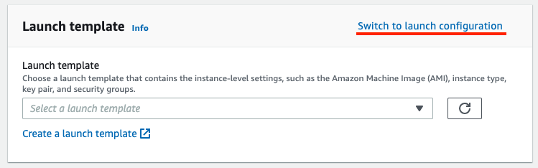
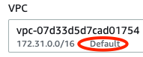
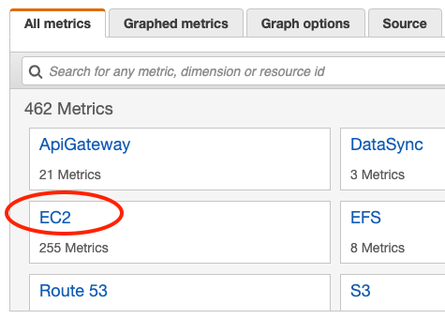
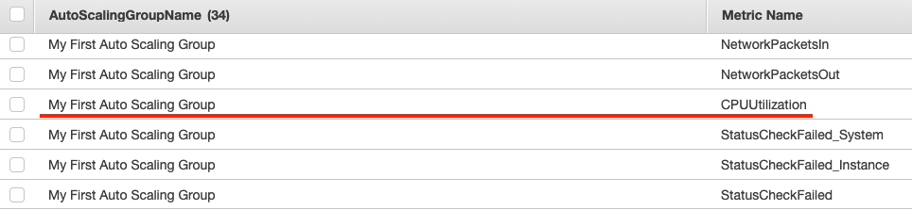

IT 321 Cloud Computing
Lab #2
Fall 2020 – Professor Josh Edgar

Our second Lab will focus primarily on Auto Scaling, one of the most powerful features in AWS and any cloud computing platform, that allows you to horizontally “scale out” additional resources when your static resources are under duress. This allows your systems to remain online perpetually, achieving “high availability” and not succumbing to heavy traffic like an on-premises environment might.

In the previous Lab, you set up a web server infrastructure that accessed files on an external file server (S3). While we won’t necessarily utilize your Web site in a highly-available fashion, we will use the instance you’ve already created in Lab #1 as a baseline for creating our AMIs and Launch Configurations in support of this Auto Scaling Lab.

What you’ll achieve:
- Create an Amazon Machine Image (AMI) from the EC2 instance you deployed in Lab #1
- Create a Launch Configuration from this AMI
- Configure an Auto Scaling Group from your Launch Configuration, to automatically deploy additional instances when the CloudWatch Alarm is triggered
- Create said CloudWatch Alarms that monitor instance CPU utilization
- Use a stress-testing tool to create fake load and force an Auto Scaling event
- Terminate resources from both Lab #1 and #2 to prevent your credit card from being charged

What you’ll turn in with this lab:
- Detailed answers to the review questions from each Task, uploaded to Canvas.

Task 1: Create an AMI and Launch Configuration

Auto Scaling Groups require Launch Configurations to know what type of EC2 instances to automatically deploy in response to a CloudWatch alarm. A Launch Configuration is based on an Amazon Machine Image, or AMI, which is effectively a Snapshot of a pre-configured instance that can be repeatedly deployed for consistency.

In this task, we will create an AMI based on your currently running EC2 instance deployed during Lab #1.

- Click the “Services” menu at the top of the AWS Management Console.
- Immediately under the “Compute” section, select “EC2.”
- On the left sidebar, under the “Instances” heading, click “Instances.”
- Right-click on the row containing details about your EC2 instance from Lab #1.
NOTE: If you deployed multiple EC2s during Lab #1 while attempting to get the Lab to work, make sure you are selecting the instance that is fully completed and that was submitted for Lab #1. You can validate this by checking that its Public DNS address matches the one you submitted to Canvas during Lab #1.
- In the menu, navigate to Image > “Create Image.”
- In the Image name field, type in “My First AMI” (without quotes).
- Leave all other options as they are, and click the blue “Create Image” button in the bottom-right of the pop-up.
- A confirmation window will appear to inform you that your “Create Image request was received.” Click the blue Close button at the bottom-right.
- On the left sidebar, under the “Images” heading, click “AMIs.”
- You should see a row entitled “My First AMI.” It’s status will likely be orange and say “pending.” Periodically click the refresh icon at the top right of the Dashboard until the status turns green and says “available.” This may take anywhere from 5 to 10 minutes.

Review Question:
10a. Under the “Platform” column for your AMI, what is displayed? (Hint: It says this because your EC2 uses CentOS, instead of AmazonLinux.) It says Other Linux. AWS automatically determines the platform by parsing the image name. For example, if Ubuntu is included in the image name, the platform will be Ubuntu. After some research, Amazon doesn't support CentOS 8, but you can bypass this by creating an EC2 snapshot and then import that as an AMI.

- On the left sidebar, scroll all the way to the bottom. Under the “Auto Scaling” heading, click “Launch Configurations.”
- At the top of the Dashboard, click the blue “Create launch configuration” button.
- On the left side of the wizard, click on the “My AMIs” tab.
- You should see your “My First AMI.” Click the blue “Select” button on the right side of your screen.
- On the next page, make sure that the row for a General purpose – t2.micro instance is selected. A green notification below t2.micro should inform you that this instance type is “Free tier eligible.” Click on the gray “Next: Configure details” button at the bottom right of your screen.
- In the Name field, type “My First Launch Configuration.”
- Click the gray “Next: Add Storage” button at the bottom right of your screen.
- Do not change anything on this page. Click the gray “Next: Configure Security Group” button at the bottom right of your screen.
- AMIs do not store Security Group settings, so we must re-add the HTTP rules we added from Lab #1 to the Launch Configuration Security Group. Ensure that that the button to the left of “Create a new security group” is selected.
- Change the Security group name field to “My Auto Scaling Security Group.”

Review Question:
20a. There is already one rule that has been added to this Security Group by default. What is it? (Provide the “Type,” “Protocol,” “Port Range,” and “Source.”)
The Type is Custom TCP rule. Protocol is TCP. Port Range is 0. The Source Type is Custom IP. The Source is Blank. We also opened port 22 for our SSH into the instance.

- Click the gray “Add Rule” button along the left side of this screen.
- A new row will appear. On this row, change the dropdown from “Custom TCP Rule” to “HTTP.” Verify that the “Source” dropdown is set to “Anywhere.”
- Ignore the warning that is displayed. Click the blue “Review” button at the bottom right of your screen.
- Click the blue “Create launch configuration” button at the bottom right of your screen.
- You will be prompted to select a key pair for the instances that are deployed as part of this Launch Configuration. Verify that the first dropdown is set to “Choose an existing key pair,” and under “Select a key pair,” make sure you select the “it321-lab1-key,” or whichever key you created that helped you successfully complete Lab #1.
NOTE: You may have multiple key pairs if you made several attempts at completing Lab #1. You can use any one of these, as long as you have the .pem (Mac) or .ppk (Windows/PuTTY) file for this key still saved on your system! If you no longer have your .pem/.ppk file for a key pair, you must change the first dropdown box to “Create a new key pair,” name it something like “it321-lab2-key,” and “Download Key Pair.” If using Windows/PuTTY, refer back to the AWS instructions on creating a .ppk file from the downloaded .pem file so that you will be able to access your new instances.
- Check the box associated with the “I acknowledge…” statement, and click the blue “Create launch configuration” button at the bottom-right of the pop-up.
- After the Launch Configuration has finished creating, click the blue “Close” button on the right-hand side of your screen.

Task 2: Create an Auto Scaling Group

Now that we have a Launch Configuration, it’s time to configure an Auto Scaling Group with defined metrics for when the configuration should be utilized.

- While still in the EC2 area of the AWS Management Console, on the left sidebar, scroll all the way to the bottom, and under the “Auto Scaling” heading, click
“Auto Scaling Groups.”
- You may be taken to the old Auto Scaling Dashboard by default. If you have a blue bubble at the top of the page that says “Try the new design for Amazon EC2 Auto Scaling,” click the link in it for “Go to the new console.”
- Once in the new Auto Scaling console, click the orange “Create Auto Scaling group” button on the landing page.
- In the “Auto Scaling group name” field, type “My First Auto Scaling Group.”
- The box below this may say “Launch template.” If so, make sure to click the “Switch to launch configuration” link in the top right of the box.
- Click inside the “Select a launch configuration” dropdown, and click on the row containing your “My First Launch Configuration” item.
- Click the orange “Next” button at the bottom of the form.
- Ensure that the VPC that is selected says “Default” underneath.
- In the “Subnets” field, click in the “Select subnets” dropdown and select the subnet associated with “us-east-1a.”
- Click the orange “Next” button at the bottom right of the form.
- On the next page, focus on the middle of the three boxes entitled “Health checks.” Below “Health check grace period,” change the field to 120 seconds.
- Click the orange “Next” button at the bottom right of the form.
- On the next page, under the “Group size” box, change the fields to reflect the following settings:
  - Desired capacity: 1
  - Minimum capacity: 1
  - Maximum capacity: 3
This tells AWS that we want our Auto Scaling Group to start with a preferred number of just one (1) EC2 instance, and that this is also the minimally acceptable number of instances. However, if scaling is needed, we are capping the maximum number of instances to three (3).
- Click the white “Skip to review” button at the bottom of the form.
- Scroll through the summary of reviewed content, ensuring that everything was configured properly, and then click the orange “Create Auto Scaling group” button at the bottom of the form.

Review Questions:
42a. On the left sidebar, under the “Instances” heading, click “Instances.”
What is happening, and why? Another Instance got launched, mostly because of the max capacity setting change through the launch configuration on the Auto Scaling group.
42b. On the left sidebar, scroll all the way to the bottom. Under the “Auto Scaling” heading, click “Auto Scaling Groups.” If prompted, click to go into the new Auto Scaling console again. Click on the name of your Auto Scaling group, then select the “Activity” tab. Observe that, under the “Activity history” box, there is a description of some activity that your Auto Scaling Group took. What did it do, and why? It's says a user request created an AutoScalingGroup changing the desired capacity from 0 to 1 and an instance was started in response to a difference between desired and actual capacity, increasing the capacity from 0 to 1.

Task 3: Create an Auto Scaling Policy with CloudWatch Alarm

In this task, we will create an Auto Scaling Policy, driven by a CloudWatch Alarm that is monitoring the CPU utilization of our instances. CPU utilization is a great metric to monitor on an EC2 instance to determine whether or not the instance is capable of serving the end users. High utilization means that the instance is reaching its capacity limits, and we want to configure our Auto Scaling Policy to respond to such an event by adding more instances (scaling out/horizontal scaling).

- While still in the EC2 area of the AWS Management Console, on the left sidebar, scroll all the way to the bottom, and under the “Auto Scaling” heading, click
“Auto Scaling Groups.” Verify that you are in the new Auto Scaling console by clicking the link in the blue bubble, as you did previously in step 29, if it appears.
- Click on your “My First Auto Scaling Group” item.
- Click the “Automatic scaling” tab.
- The first heading that appears under this section is labeled “Scaling policies (0).” This means we currently have no scaling policies applied, so our Auto Scaling Group isn’t doing much of anything right now. Let’s change that.
- Click on the white “Add policy” button in the right side of this section.
- Change the “Policy type” dropdown to “Simple scaling.”
- Change the “Scaling policy name” field to “My Scale-Out Policy.”
- Under the dropdown box for “CloudWatch alarm,” click on the blue link that says “Create a CloudWatch alarm.”
- A new window/tab will open and take you to the CloudWatch alarm creation wizard. Click on the white “Select metric” button.
- A pop-up will appear. Towards the bottom left of this pop-up, click on the box that says “EC2” to look at the types of EC2-related metrics CloudWatch can monitor.
- When the next set of boxes appears, click “By Auto Scaling Group.”
- Scroll through this list to find a metric for your “My First Auto Scaling Group” name that is associated with the “CPUUtilization” metric.
- Check the box for this row, then click the blue “Select metric” button at the bottom-right of the pop-up.
- Back in the CloudWatch wizard, scroll down to the box labeled “Conditions.” The threshold type should already be set to “Static” and the “Greater >” threshold should be selected. In the field below “than…,” type 50, and click the orange Next button at the bottom right of the form. (This configures our CloudWatch Alarm to trigger whenever the average CPU utilization of instances in our Auto Scaling Group exceeds 50%.)
- On the next page, in the “Notification” box, verify that “Alarm state trigger” is set to “In alarm.” Under the “Select an SNS topic” section, click the button to the left of “Create new topic.”
- In the “Create a new topic…” field that appears, type in “MySNSTopic” (without quotes or spaces).
- In the field beneath “Email endpoints that will receive the notification…,” type in your
e-mail address.
- Click the white “Create topic” button.
- Skip past the “Auto Scaling action” section, as this only works with certain types of Auto Scaling Policies that we won’t cover in this course. Click the orange “Next” button at the bottom right of the form.
- In the “Alarm name” field, enter “CPU Utilization Exceeds 50%” (without quotes).
- Click the orange “Next” button at the bottom right of the form.
- Scroll through the review page, making sure that your configurations were accepted correctly, and then click the orange “Create alarm” button at the bottom of the form.
- Keep this window/tab open, and open another to check your e-mail. You will have an e-mail from “AWS Notifications” with a link asking you to “Confirm subscription.” Click this link, and then close the window/tab that was opened to confirm your subscription.
- Go back to the first window/tab that still has our “Create scaling policy” form, and click the small refresh button next to the CloudWatch alarm dropdown.
- Click inside the CloudWatch alarm dropdown again, and you should have an option for the “CPU Utilization Exceeds 50%” alarm that you just created. Select it.
- Under the “Take the action” section, change the middle field to 1, so that the full statement reflects “Add 1 capacity units.”
- Under “And then wait,” set this to 120 seconds before allowing another scaling activity.
- Click the orange “Create” button at the bottom right of the form.

- Repeat steps 47 through 70, but with the following modifications:
  - This scaling policy’s name will be “My Scale-In Policy” (without quotes).
  - When creating a new CloudWatch alarm, use the same CPUUtilization metric for the same Auto Scaling Group name, but in the “Conditions” box, change the threshold to “Lower <” and set the number to 40.
  - In the “Notification” box, do not create a new topic again. Select the option for “Select an existing SNS topic,” click in the field below “Send a notification to…” and select the “MySNSTopic” that you’ve already created.
  - This alarm’s name should be “CPU Utilization is Below 40%” (without quotes).
  - Back in the scaling policy configuration, “Take the action” should be set to “Remove 1 capacity units.” Make sure to change all fields to reflect this statement.

Review Question:
71f. Include a screenshot of your “Automatic scaling” tab showing both of the scaling policies that you created, so that the professor can verify that they were configured correctly.
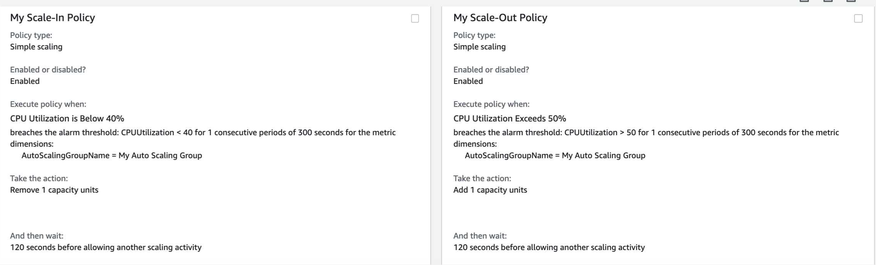
Task 4: Stress Your EC2 Instance

Now that we’ve done all of the work associated with setting up a Launch Configuration, Auto Scaling Group, and Auto Scaling Policies/CloudWatch Alarms for scale-out and scale-in, it’s time to test our Policies by stress-testing the default EC2 instance in the Group, and seeing if the Policies respond appropriately by scaling our infrastructure.

- While still in the EC2 area of the AWS Management Console, on the left sidebar, under the “Instances” heading, click “Instances.”
- Click on the row that contains the default EC2 instance that was created by the Auto Scaling Group. (Hint: It won’t be the EC2 instance you used from Lab #1, and it probably has a blank space instead of a name).
- Make a note of the “IPv4 Public IP” that appears in the Description section at the bottom of the EC2 Dashboard.
- Connect to this EC2 instance by following the same steps you did in step 62 of Lab #1, but using the IP address from step 74 of this Lab instead.
NOTE: Mac users can skip the step to “chmod” their .pem file, and Windows users can skip the step of using PuTTYgen to make a .ppk file, as these are one-time tasks that you’ve already done during the first Lab.
- Once presented with your prompt that begins with “centos,” run the following command to become the “root” user:
sudo su
- Run the following command to install the epel-release repository, which is required so that we can locate the stress-testing tool.
yum -y install epel-release
- Now, run the following command to install our stress-testing tool:
yum -y install stress
- Once presented with the “Complete!” message and returned to a prompt, run the following command to begin a stress test of this instance’s CPU:
stress --cpu 12 --timeout 660
- You will receive a message about “stress: info: Dispatching hogs” and be unable to use your terminal for 11 minutes (660 seconds). Remember that our CloudWatch alarms were configured by default to only check the status of our instances every five (5) minutes, which is why we’ve set our stress test to at least cover two (2) status checks.

Review Questions:
79a. While this is happening, head back to the AWS Management Console, and periodically click the refresh icon at the top right of the Dashboard. After a few minutes, what happens? Why? A third instance was spun off because it hit the cpu utilization % required to do so (This is the 2nd alarm, 2 instances have now changed to 3)
79b. Assuming something is happening in Question 79a, click the “Services” menu at the top of the AWS Management Console, and in the second column under the “Management & Governance” section, click “CloudWatch.” Click on the “Alarms” link in the left sidebar. What “state” is your “CPU Utilization Exceeds 50%” alarm in? The State for this creation is in the Alarm State Moved from the OK state.
79c. You should have received another e-mail from “AWS Notifications.” What is this
e-mail telling you? We got an email stating: You are receiving this email because your Amazon CloudWatch Alarm "CPU Utilization Exceeds 50%" in the US East (N. Virginia) region has entered the ALARM state.

- Navigate back to your EC2 Instances list, and keep clicking the refresh button. As long as our stress test continues, you should see at least one more instance appear. If you do not see this third instance appear, and your stress test has completed with a message in your terminal about “successful run completed,” run the command from step 78 again.

Review Questions:
80a. As the stress test continues, why does only a maximum of three (3) instances deploy? Why wouldn’t we see a fourth (4th) one deploy during our stress test? Because our Max Capacity policy was set to 3 earlier from the auto scaling group. So it will not go to number 4
80b. Run the below command on your terminal: uptime
The first number after “load average” is a whole-number representation of CPU utilization. 1.00 = 100%. What is your instance’s current CPU utilization? Why did this trigger the scaling events you’ve observed?
Our Uptime: 21:10:17 up 4:12, 2 users, load average: 2.10, 7.54, 5.75
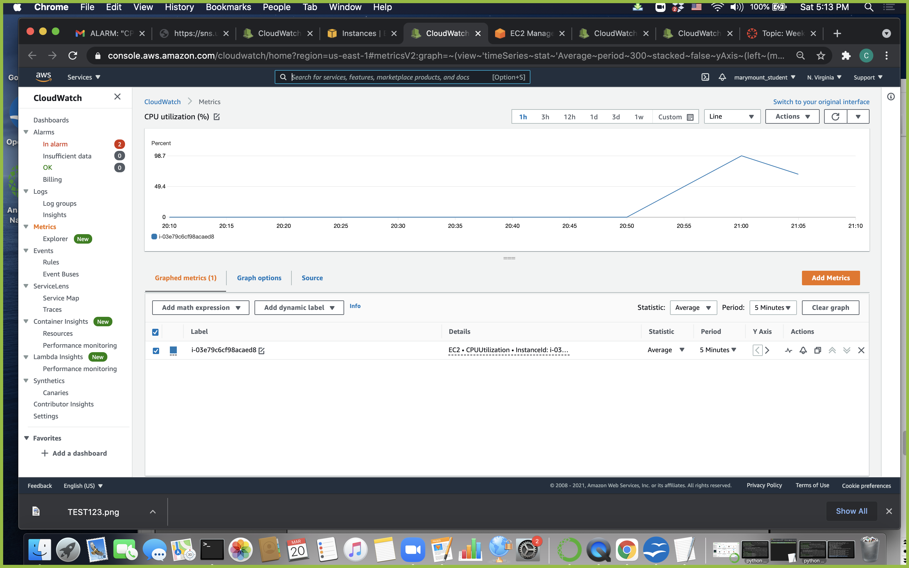
Average CPU UTILIZATION Chart:

Since, CPU UTILIZATION went over the given threshold through the cloudwatch, it triggers the Autoscaling policy rules to add one more instance. So the instance changed from 2 to 3. In another scenario, if the cloudwatch goes under the threshold % it can also trigger a remove instance also, but our policy says minimum one instance and 3 max instances.

- After you’ve completed all of the stress testing you wish to conduct, and have received your final “successful run completed” message in the terminal, take at least a 30-minute break. Grab a snack, walk your dog, or re-read your entire textbook cover-to-cover to prepare for your final exam.

Review Questions:
81a. In the AWS Management Console, navigate back to your list of EC2 instances and click the refresh icon at the top right of the Dashboard. What has changed about your list of instances? (Hint: Pay close attention to the “Instance State” column.) Why? One of the Instance got changed to the terminated status, this is because the cpu percentage went down during our time of break, most likely.
81b. When you come back, your terminal session may have timed out. Re-connect to your instance following the instructions from step 75, and become root as described in step 76. Run uptime again. What is your instance’s CPU utilization now? How is this relevant to your answer for Question 81a?
Uptime: 23:33:06 up 6:35, 2 users, load average: 0.00, 0.01, 0.05
Our Overall CPU UTILIZATION went around to 20%

This relates to 81A because it shows the reduction of auto scaling due to the end of stress-testing. This also shows the overall cpu utilization % went down.

81c. Check your e-mail. Do you have another e-mail from “AWS Notifications?” If so, what is the most recent e-mail telling you? Yes, we got another email stating that the CPU UTILIZATION is less than 40% and it removed one instance and has also left the alarm state to ok state from cloudwatch.

Task 5: Clean-Up of Both Labs

AWS Free Tier generously gives us a lot of free credit to use for these Labs, but we need to make sure that we terminate any resources that we aren’t using so that we can conserve our credits for other projects (and make sure that we aren’t charged real money when our year of Free Tier expires!)

- On the left sidebar of the EC2 section of the AWS Management Console, scroll all the way to the bottom, and under the “Auto Scaling” heading, click “Auto Scaling Groups.”
If you are prompted again about using the new console, ensure that you follow the link to use that new console.
- Verify that “My First Auto Scaling Group” is checked, and click the white “Delete” button at the top right of the table.
- You will be prompted to confirm deletion by typing “delete” (without quotes) in the field. Do this, and then click the orange “Delete” button.

Review Question:
84a. In the AWS Management Console, navigate back to your list of EC2 instances and click the refresh icon at the top right of the Dashboard. Something has changed once again about your list of instances. What has happened now? Why do you think it has happened? One Instance has been removed. This is because the autoscaling no longer linked to that instance after deletion. There is now only one instance left.

- On the left sidebar, scroll back to the bottom. Under the “Auto Scaling” heading, click “Launch Configurations.”
- Right-click on the row that contains “My First Launch Configuration” and select “Delete launch configuration.” When prompted, confirm the deletion by clicking the blue
“Yes, Delete” button in the pop-up.
- On the left sidebar, under the “Images” heading, click “AMIs.”
- Right-click on the row that contains “My First AMI” and select “Deregister.” When prompted, confirm the de-registration of your AMI with the blue “Continue” button.

The following steps will terminate your resources from Lab #1. If you intend to build upon your infrastructure from Lab #1 for your Final Project (Infrastructure Option), or want to keep those resources for any reason, DO NOT perform these steps.

- On the left sidebar, under the “Instances” heading, click “Instances.”
- Check the boxes next to any remaining instances that you no longer intend to use. Click the gray “Actions” dropdown button at the top of the table, and select “Instance State > Terminate.” When prompted to confirm, click the blue “Yes, Terminate” button at the bottom-right of the pop-up. This cannot be undone.
- Click the “Services” menu at the top of the AWS Management Console.
- Under the “Storage” section, click “S3.”
- Check the box next to your S3 bucket name, and click the white-and-blue “Delete” button at the top of the table. You will be prompted to enter the name of your bucket perfectly to confirm deletion.

That’s it! You have successfully created all of the necessary configurations to make an AMI based on your EC2 instance from Lab #1, create a Launch Configuration with a custom Security Group (even though we didn’t use it, this is an important step if you were intending to scale-out your Web site), and configure the necessary Auto Scaling Policies and CloudWatch Alarms to respond to your instance’s CPU utilization. Large businesses all over the globe have performed the same steps you did to ensure their systems are always highly-available. It wasn’t that hard, was it? Just one of the many cool, powerful features of cloud computing and AWS!

